# 

# Assignment No: 08

# Aim - Create an android app to Connect to the Internet and use BroadcastReceiver.

**customdialog.xml**

*<?*xml version="1.0" encoding="utf-8"*?>*

<LinearLayout xmlns:android="<http://schemas.android.com/apk/res/android>" android:orientation="vertical" android:layout_width="match_parent" android:background="#024BFF"

android:gravity="center" android:layout_height="match_parent">

<ImageView android:layout_width="120dp" android:layout_height="120dp" android:src="@drawable/no_internet" android:layout_gravity="center"/>

<TextView android:layout_width="match_parent" android:layout_height="wrap_content" android:text="Ooops!" android:gravity="center" android:textColor="#FFF" android:textSize="40sp"/>

<TextView android:id="@+id/nettext"

android:layout_width="match_parent" android:layout_height="wrap_content" android:text="No Internet Connection found" android:textColor="#FFF" android:textSize="15sp" android:layout_marginBottom="10dp" android:gravity="center"/>

<TextView android:layout_width="match_parent" android:layout_height="wrap_content"

android:text="ON YOUR DATA AND HIT RESTART"

android:textColor="#FFF" android:textSize="15sp" android:layout_marginBottom="10dp" android:gravity="center"/>

<Button android:id="@+id/restartapp" android:layout_width="300dp" android:layout_height="50dp" android:text="Restart" android:textSize="20sp"

android:background="@android:color/holo_green_light"/>

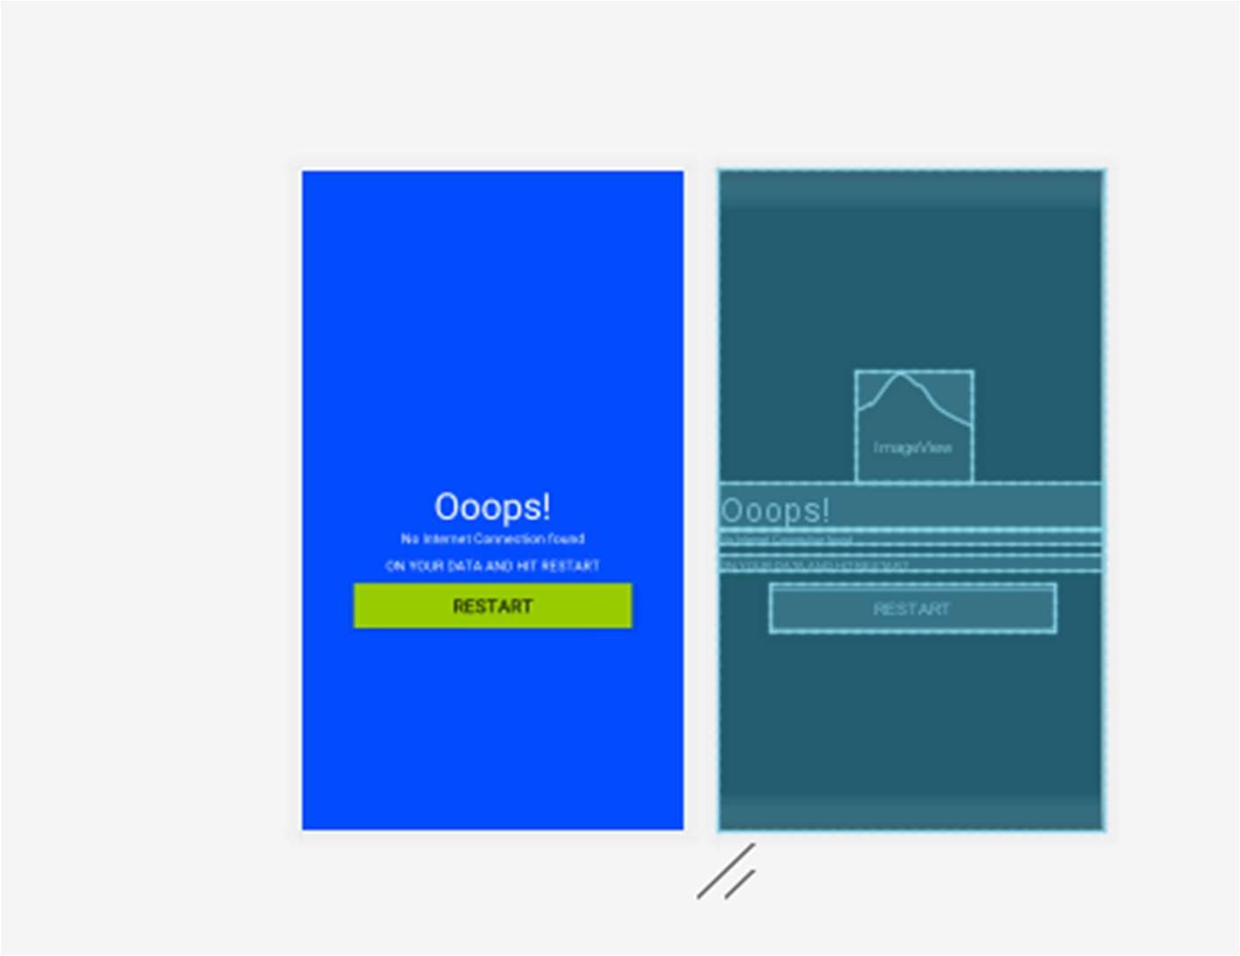</LinearLayout>

# Network_util.java

import android.content.Context;

import android.net.ConnectivityManager; import android.net.NetworkInfo;

class NetworkUtil {

public static String getConnectivityStatusString(Context context) { String status = null;

ConnectivityManager cm = (ConnectivityManager) context.getSystemService(Context.*CONNECTIVITY_SERVICE*);

NetworkInfo activeNetwork = cm.getActiveNetworkInfo(); if (activeNetwork != null) {

if (activeNetwork.getType() == ConnectivityManager.*TYPE_WIFI*) { status = "Wifi enabled";

return status;

} else if (activeNetwork.getType() == ConnectivityManager.*TYPE_MOBILE*) { status = "Mobile data enabled";

return status;

}

} else {

status = "No internet is available"; return status;

}

return status;

}

}

# AndroidManifest.xml

*<?*xml version="1.0" encoding="utf-8"*?>*

<manifest xmlns:android="<http://schemas.android.com/apk/res/android>" xmlns:tools="<http://schemas.android.com/tools>" package="com.example.broadcastreceiverapplication">

<application android:allowBackup="true" android:icon="@mipmap/ic_launcher" android:label="@string/app_name"

android:roundIcon="@mipmap/ic_launcher_round" android:supportsRtl="true" android:theme="@style/AppTheme">

<activity android:name=".MainActivity">

<intent-filter>

<action android:name="android.intent.action.MAIN" />

<category android:name="android.intent.category.LAUNCHER" />

</intent-filter>

</activity>

<receiver android:name = "MyReceiver">

<intent-filter>

<action android:name = "android.net.conn.CONNECTIVITY_CHANGE" tools:ignore="BatteryLife" />

<action android:name = "android.net.wifi.WIFI_STATE_CHANGED" />

</intent-filter>

</receiver>

</application>

<uses-permission android:name="android.permission.ACCESS_NETWORK_STATE"/>

</manifest>

# MyReceiver.java

import android.app.Activity; import android.app.Dialog;

import android.content.BroadcastReceiver; import android.content.Context;

import android.content.Intent; import android.util.Log; import android.view.View; import android.widget.Button;

import android.widget.TextView; import android.widget.Toast;

import com.example.broadcastreceiverapplication.MainActivity; import com.example.broadcastreceiverapplication.R;

public class MyReceiver extends BroadcastReceiver { Dialog dialog;

TextView nettext; @Override

**public void onReceive(final Context context, final Intent intent) { String status = NetworkUtil.*getConnectivityStatusString*(context);**

**dialog = new Dialog(context,android.R.style.*Theme_NoTitleBar_Fullscreen*); dialog.setContentView(R.layout.*customdialog*);**

Button restartapp = (Button)dialog.findViewById( R.id.*restartapp*); nettext =(TextView)dialog.findViewById(R.id.*nettext*);

restartapp.setOnClickListener(new View.OnClickListener() { @Override

public void onClick(View v) { ((Activity) context).finish(); Log.*d*("clickedbutton","yes");

Intent i = new Intent(context, MainActivity.class); context.startActivity(i);

}

});

Log.*d*("network",status);

if(status.isEmpty()||status.equals("No internet is available")||status.equals("No Internet Connection")) {

status="No Internet Connection"; dialog.show();

}

**Toast.*makeText*(context, status, Toast.*LENGTH_LONG*).show();**

}

}

# MainActivity.java

package com.example.broadcastreceiverapplication; import android.content.BroadcastReceiver;

import android.content.IntentFilter; import android.net.ConnectivityManager; import android.os.Bundle;

import androidx.annotation.Nullable;

import androidx.appcompat.app.AppCompatActivity; public class MainActivity extends AppCompatActivity{

private BroadcastReceiver MyReceiver = null; @Override

protected void onCreate(@Nullable Bundle savedInstanceState) { super.onCreate(savedInstanceState); setContentView(R.layout.*activity_main*);

MyReceiver = new MyReceiver(); broadcastIntent();

}

public void broadcastIntent() { registerReceiver(MyReceiver, new

**IntentFilter(ConnectivityManager.*CONNECTIVITY_ACTION*));**

}

@Override

protected void onPause() { super.onPause();

**u**nregisterReceiver(MyReceiver);

}

}

# Output:

